
http://www.clinecta.com

White paper: The Meeting Matrix Collaboration Software

Introduction:
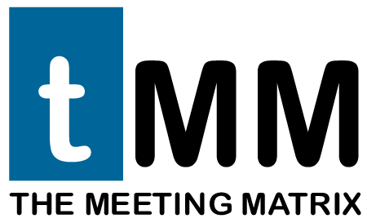
When we designed The Meeting Matrix, we started by studying how groups of people operate, how they interact with one another, as well as how they exchange information. We started with the knowledge that some of the most important needs that organizations have are: Coordination, the ability to rapidly receive and disseminate information, and the ability to accurately relay information in the most effective way possible.
As the Internet evolved, these groups embraced the disparate technologies of voice communications, email, instant messaging, and desktop sharing to help fill these needs. Voice communications have added multiple layers of availability, portability, and functionality. Email systems have helped in coordinating geographically remote participants in groups, and those users in workgroups that cut across business and functional lines of authority. Instant messaging (IM) has proven to be a great mechanism to enable messaging system users to send quick messages, receive responses, and quickly have the messages disappear from the screen. We know the graphic/visual component of messaging is extremely important – the expression "a picture is worth a thousand words" served as our guide. Desktop sharing is an excellent way to graphically share “the picture”, but traditionally lacks annotation tools and the ability to traverse firewalls and proxies.

The Meeting Matrix challenge has been to aggregate IM and desktop sharing technologies and others into a cohesive enterprise collaboration solution with centralized management and security. Now add ubiquitous access capabilities for those inside and outside the organization, and the ability to operate in the complicated and often prohibitively complex environment of the Internet with its mix of firewall and proxy technologies. Then embrace the existing, proven technologies of email and the PSTN (Public Switched Telephone Network) phone system. The result is a system with powerful relational databases at the heart, a resident Windows client with IM styled interface on the desktop, and a lightweight browser-based client for those outside the organization.
Presence Detection
Before collaboration begins, participants need to be identified as being available and open to the interchange. A key component of the Meeting Matrix is presence detection and message notification. Presence Detection is the electronic equivalent of popping your head over the cube or into an office door to gauge the receptiveness of a colleague to a conversation at that very moment. Office workers would like to have systems that mimic or support how they work – not turn them around to support the system. If you are not at your desk (or are busy on the phone or in a meeting) you can indicate that in your online profile. A message window pops up from an associate and you decide if you want to multi-task by directly interacting with them, or drag and drop a canned response from the database – “can’t talk now…in a meeting”. The user can choose from a list of availability options or define their own.
The Meeting Matrix presence detection can be embedded in other applications. For example, your organization already has a web-based trouble ticketing system. Now you can embed the presence of a service person directly into the application. That static open ticket can now reflect the person assigned AND their presence in the office and willingness to talk about the issue.

Instant Messaging

Instant Messaging is a concept that is growing in popularity as both the business and technology leaders in organizations search for ways to improve productivity by lowering costs and improving the efficiency of group and one-on-one communications. Instead of sending an email to a colleague who wants to see a spreadsheet file, just pop them an instant message then drag and drop the file to send to them. The email system is likely not to be checked every 5 minutes; in fact, email users have trained themselves to not look at their email bin every time something comes in. Why? Most of their email is garbage! Instant Messaging, on the other hand, implies a higher sense of importance and immediacy. As a way of communicating, users have found messaging and email technologies to be complementary. Large email systems are overloaded and are not organized for the instant messaging required for effective group interaction.
The Meeting Matrix embraces the immediacy of IM as the central metaphor for its operations. Most other collaboration tools on the market require you to schedule a ‘meeting room’ and offer invitations to meet at some time in the future. We feel its better to let events unfold as they happen allowing work and collaboration to flow as naturally as possible as it does in the current brick and mortar environment. How many great ideas have been lost in a chance meeting? In the hall? In a discussion? Or directly after the ‘meeting’ has adjourned? With instant messaging, your thoughts are instantly projected, archived, and your response can be equally as instant. Your direct IM contact URL can be placed in your email signature or added to your email profile inviting your recipient to click on it at anytime to contact you. If, during a collaboration session the need arises to bring in another participant as it often does in the office, simply open the conference invitation window and choose from available colleagues to invite.
The Meeting Matrix offers centralized management of your IM domain. Create / Edit/ Delete accounts from the administration interface. Assign the team member to a group(s). Concerned about unauthorized IM use? The Meeting Matrix stores all the IM conversations in your organization in a central database to be reviewed or mined later. We encrypt IM conversations with 128 bit encryption techniques. Ubiquity of communication options is desirous, so we’ve included gateways to the major IM networks – AOL, MSN, and Yahoo all in the same interface. Conversations on these networks are also data warehoused.
Maybe your student, client or patient doesn’t use an IM tool ,this problem can be easily solved. We will place a link on a web page with a script we provide. We create a customized welcome screen, with your branding and identity. Visitors can then submit their profile information and we launch a lightweight client (as little as 128 kilobytes in size). Now they can instantly talk directly to an individual or be placed into a queue to speak with the next available agent.
Desktop Sharing
With a shared desktop and a small amount of annotation, you can save significant time exchanging information. Graphical messaging may account for 50% of effective communications if implemented correctly. Graphical messaging can also cut down the amount of time one spends explaining questions in more detail or in providing a thorough response.
The Meeting Matrix Desktop sharing technology has been fine-tuned to allow for rapid screen rendering even on low speed dialup connections by using customizable jpeg compression and screen-rendering methodologies that optimize the sending of only changed information. We support the sharing of the entire desktop, a portion of the desktop, or an application window exclusively. The owner of the desktop can annotate the desktop or application window with paint tools. In a The Meeting Matrix conference, all the participants can share their desktops.
A key feature in our desktop sharing is that it loads dynamically on-demand which benefits your support organization by allowing for centralized management, centrally controlled updates, no lingering impact on the desktop environment, and ubiquitous OS support. For example, it is possible to support Windows, Mac, and Linux desktops all in the same conference. Of course, we can share through firewalls, proxy servers, and on NAT clients. The network bandwidth impact is variable depending on the compression methodology chosen and the aggressiveness of the content sharing. The range is 0 kbps with no activity to 14kbps in an active session per session.
Optional Modules
PSTN Conferencing
VOIP is great, but lets face it, the public switched telephone network (PSTN) offers ubiquitous support, unparalleled voice clarity, and perhaps most importantly robustness of connection. That’s why The Meeting Matrix incorporates PSTN conferencing with an application interface. If the need to supplement your IM conversation with a customer with a phone call dynamically arises, the Meeting Matrix can pull the phone number from their profile (and yours) and connect the 2 of you with a mouse click. Need to bring in your engineer and a vendor? Pull up your phone book or pop them an instant message if they are online, select the additional participants and the Meeting Matrix connects you, instantly.
We bill by the minute in 6-second increments for each leg of the conversation. Online usage reports allow you to control your phone conferencing costs.
Voice over IP (VOIP)
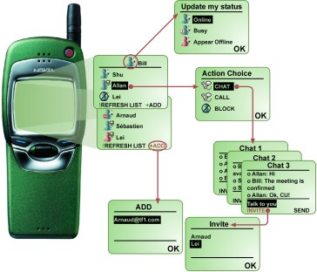
The Meeting Matrix VOIP Module allows for a voice chat room of up to 500 participants. All the participants require is a PC running Windows 98 or higher with a SoundBlaster compatible sound card, microphone and speakers. The voice quality is configurable to support near telephony quality with lesser quality available to conserve network bandwidth. The range of data rates is 9-20 kbits/sec per leg depending on the voice quality chosen allowing for superb quality even over slower dialup connections. The client side interface loads dynamically from the server. Firewall traversal is engineered into the product meaning your corporate firewalls (and those of the participants) don’t need to be touched. The VOIP needs its own application server and supports Windows98/NT/2000/XP (preferably Windows 2000 or XP). The server can be remotely managed through a remote GUI interface, which includes a real-time active user monitor.
At Clinecta, we recognize the fact that your online communities capabilities changes by the hour. Phone lines go down in storms, cell phone systems can become overloaded and Internet providers can experience down times. By offering your users the ability to conference by IM, VOIP or PSTN, your community has the greatest chance to be able to fully participate in the greatest number of classes, meetings or ‘brainstorming sessions.
Video Conferencing
The Meeting Matrix video conferencing module provides for low bandwidth, firewall and NAT compatible video connections. Bandwidth conservation is achieved by the ability to select between an “icon” sized video window, to a high quality image of 5 to 20 frames per second up 120x90 pixels. Further quality selections allow for varying rates of mpeg compression.
Web Co-Browse and Form Co-Share
The Meeting Matrix Co-browse features allows for synchronized web browsing. This feature is useful when the person in control of the session wishes to direct a participant to a particular URL or Web destination. Co-sharing allows for the collaborative filling of web based form fields. Each of these technologies are selectively bi-directional allowing either participant to be in control. At the start of a co-browse/co-share session, a special browser is dynamically loaded to support these features.
The Meeting Matrix Component Feature Check list:
Windows Client (Agent):
Agent-to-client instant messaging
Agent-to-agent instant messaging
Departmental Grouping
Secure IM protocol (128 bit encrypted messaging)
File Transfer
Remote Desktop Sharing
Remote Desktop Control
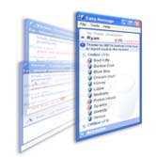
Web Co-browsing
Web Co-Sharing
Video Conferencing
Voice Over IP Conferencing
Multi-user chat
Agent-to-Agent Client/Visitor Transfer
Visitor Profile Review
Visitor Contact History Review.

Visitor Client:
Client-to-agent instant messaging
Voice Over IP Conferencing
Video Conferencing
Group Chat Participation
Clickable URL’s
Web Co-Browsing
Web Co-Sharing
Desktop Viewing
Remote desktop control.

Conferencing

Web-based, virtual conferencing has quickly emerged as an invaluable resource to many organizations. The real-time exchange of ideas and information coupled with tremendous costs savings are just a few of the benefits that can be quickly measured in financial terms. The ability to decrease travel expenses without decreasing levels of interpersonal communication are advantages that are so compelling, most organizations are quickly adopting virtual conferencing into their cultures. the Meeting Matrix can easily and naturally connect all of your remote facilities and people worldwide.

Multi Person Chat
Video Conferencing
Voice Call Conferencing (Traditional Telephone Networks)
Voice Call Conferencing (Voice Over IP)
Group Application Sharing
One-to-Many file transfer
White Boarding
Firewall Negotiation

Collaboration

As organizations continue to strive to build networks of teamwork and collaborative effort, the need for collaboration tools has grown substantially. Teams of individuals are faced with the challenge of finding ways in which to share enough information about a project, while at the same time, avoiding the confusion of duplicating efforts, documenting progress, and archiving accomplishments, responsibilities, and goals. the Meeting Matrix offers a centralized, automated, and single communications tool to facilitate one-to-one, one-to-many, and group collaboration.

Scheduled Group Meetings
Application Sharing
Desktop Sharing
File Transfer
Web Co-Browsing
Remote Desktop Control
Remote Desktop Sharing
Delegated and Shared Meeting Facilitation
Video Conferencing
Voice Conferencing
White Boarding
Voice and Text Archiving and Retrieval

Secure Communications

Security has come to take on several meanings today. Secure communications is, for many organizations, a requirement by federal and industry regulations. While many organizations face the dilemma of implementing security measures where very little or none have existed before. the Meeting Matrix offers secure communications at every level of it’s functionality. Encryption, firewall compliance, and the ability to isolate a the Meeting Matrix implementation are just some of the security issues the Meeting Matrix addresses. Regardless of your security policies, goals, or requirements the Meeting Matrix has been designed with security as a primary consideration.

Firewall Compatibility
NAT Compatibility
Text Encryption
Data Encryption
Video Encryption
Voice Encryption
Encrypted Archival
Password Protection and Authentication
SSL Integration
Secure Web-based Administration
Server-Based Conference and IM Archives

The Meeting Matrix Key Features:

Instant Messaging
- One-to-one Instant Messaging
- Presence Detection
- Intelligent Visitor Routing
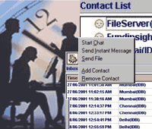
- AOL©/AIM©, MSN©, and Yahoo!© Compatibility

Conferencing
- Multi Person Chat
- Video Conferencing
- Voice Call Conferencing (Traditional Telephone Networks)
- Voice Call Conferencing (Voice Over IP)

Collaboration
- Application Sharing
- Desktop Sharing
- Remote Desktop Control
- File Transfer
- Web Co-Browsing (For use with optimized web pages)

Secure Communications
- Firewall Compatibility
- NAT Compatibility
- Text Encryption
- Data Encryption
- Web Administration
- Server-Based Conference and IM Archives

The Meeting Matrix Key Advantages

- the Meeting Matrix Offers a Single Point of Ubiquitous Communications including Phone, email, IM, video conferencing and web collaboration
- Dynamic Conference Calling and Web meetings No scheduling necessary
- Can Be Enterprise Hosted or, Remotely Hosted
- Extensive Firewall Negotiation and Compliance
- Configurable Agent Features and Limitations (Modular Design)
- Centralized User Management and Supervision
- Centralized Communications Archive and Repository
- Customizable Reporting Features
- Offers Clients and Employees Multiple Avenues of Communications NO DEMAND
- Secure and Encrypted Messaging
- IM, VoIP, Video, and Web Conferencing
- Compatible with AOL, Yahoo, Microsoft IMFlexible Collaboration Capabilities

Professional Services

- Installation and Configuration
- Training
- Technical Support
- Consulting, Custom Development, and System Integration

Installation and Configuration


the Meeting Matrix Project Managers will coordinate with your IT staff, our Software Engineers and our Implementation Engineers to deliver your the Meeting Matrix implementation in a professional, efficient, and effective manner. Clinecta Technical Support Agents can provide additional offsite installation support.

Training

Clinecta is an educational industry innovator with our Learning Matrix educational delivery methodologies. Clinecta can provide extensive online virtual classroom training, demonstration, and documentation.

Technical Support

Clinecta will provide extensive documentation for the Meeting Matrix end-users, administrators, and managers. We can provide a traditional tiered support structure and we can also support our products using the Meeting Matrix itself for instant troubleshooting and problem resolution.

Consulting, Custom Development, and System Integration

The Meeting Matrix development team and our Software Engineers can provide extensive integration with existing systems. On a per project basis, we will assist you in co-branding the Meeting Matrix, sharing the Meeting Matrix data with other applications, and building customized the Meeting Matrix features for your organization. These assets will help you to design the best model of the Meeting Matrix for your organization and allow you to fully guide its usefulness, integration, and plan for future enterprise expansion.

Hardware and Operating System Requirements and Specifications

The Meeting Matrix Server Specifications
- Operating System: Windows 2000 Server or, Windows 2000 Advanced Server
- Processor: 2.0 GHz Pentium 4 (Pentium 4 Xeon and multi-processor configurations are available)
- Memory: 1-4 GB RAM
- Display: 800 x 600 VGA graphics (console switchbox ready)
- Network Adapter: Ethernet adapter (single and dual adapters are available)
- Web Server: Internet Information Server (IIS) 5.0
- Web Browser: Internet Explorer 5.5, Netscape 7.0 or, Mozilla 1.0 or greater
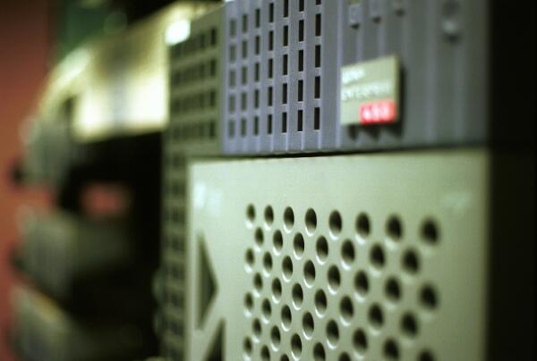
- Network Connection: DSL or greater broadband connection
- Database: Oracle or, SQL Server
- Sessions: 2000 per server. Servers can be clustered for more capacity.

The Meeting Matrix Agent Platform
- Operating System: Windows 98/ME/NT/2000/XP
- Processor: 600 MHz Pentium II or greater
- Memory: 64 MB RAM
- Display: 800 x 600 VGA graphics
- Network Adapter: Ethernet or Modem adapter
- Web Browser: Internet Explorer 5.5, Netscape 7.0 or, Mozilla 1.0 or greater
- Network Impact: 28Kb/sec (Instant Messaging), 28Kb/sec (VoIP), 56Kb/sec or faster (Video)
- Video Camera: USB or parallel port Web camera
- Voice and Sound: SoundBlaster or equivalent sound card

The Meeting Matrix Web Client Platform (Visitor)
- Operating Systems: Windows 95/98/Me/2000/XP
- Web Browser: Internet Explorer 5.5, Netscape 7.0 or, Mozilla 1.0 or greater
- Network Impact: 28Kb/sec (Instant Messaging), 28Kb/sec (VoIP), 56Kb/sec or faster (Video)
- Video Camera: USB or parallel port Web camera
- Voice and Sound: SoundBlaster or equivalent sound card
NOTES:

